INTERFAITH YOUTH INITIATIVE SUMMER FELLOWSHIP APPLICATION FORM

PLEASE SUBMIT APPLICATIONS BY May 15th, 2020

Shelton Oakley Hersey, IFYI Program Director
Cooperative Metropolitan Ministries
474 Centre Street, Newton, MA 02458
IFYI@coopmet.org

We are able to take students entering their sophomore, junior or senior year of high school as well as recent high school graduates (ages 15-19). Students in these age groups are greatly encouraged to apply! We are excited to receive your application and welcome you to contact us by email should you have any questions or concerns that arise in the application process.

Personal Information
Name (Last, first, M.I.) __________________________________________________________________
Permanent Address_____________________________________________________________________
_____________________________________________________________________________________
Mailing Address (if different) _____________________________________________________________
_____________________________________________________________________________________
Cell Phone__________________________ Home Phone _______________________________________ Email________________________________________________________________________________
Date of Birth_________ Gender_______ Grade as of Fall 2018 __________________________________
High School and Front Office Administrator or Guidance Counselor and Phone Number______________________________________________________________________________
Health conditions (yes/no) explain _________________________________________________________

Dietary restrictions _____________________________________________________________________
If I am accepted, I am requesting (check all that apply):
Halal food___________Kosher food_________Vegetarian food__________Other: __________________

Name of parent/guardian 1_______________________________________________________________
Parent/guardian 1 phone ________________________________________________________________
Parent/guardian 1 Email _________________________________________________________________
Name of parent/guardian 2 (if applicable) ___________________________________________________
Parent/guardian 2 phone ________________________________________________________________
Parent/guardian 2 email _________________________________________________________________

Religious Involvement
Religious affiliation (if any, not required) ____________________________________________________
Name of religious community, location (if applicable) _________________________________________
Religious leader/educator and contact information____________________________________________
_____________________________________________________________________________________
How does this person know you? __________________________________________________________

How did you hear about IFYI? (Circle all that apply)

Religious Leader (Imam, Pastor, Rabbi, etc.) Religious Educator Youth Advisor

Flier Social Media At School Friend IFYI Alumni (Name)_______________________

Other (Please specify) ___________________________________________________________________

Reflections (Please write on a separate page.)
In three substantive paragraphs, please tell us about yourself. Please be sure to address all the areas mentioned below. There are no right or wrong answers. Feel free to write in the manner that best helps you communicate your thoughts.

- What significant moments or people in your life have influenced who you are today?
- What leadership, faith, or service activities have you been involved with in the past? (You can think creatively in terms of your role in your family, peer group, sports or other activities.)
- Why do you want to be an Interfaith Youth Initiative Summer Fellow? What do you think might be challenging for you? What do you hope to learn or gain? What do you feel is the most important conversation we should be having?

How do you or might you like to express yourself, your beliefs, your ideas, etc.? (Circle all that apply.)

Writing (any style: blog, poetry, spoken word) Visual Art Drama Film

Dance/Movement Music Other (dream big and specify) ___________________________
_____________________________________________________________________________________

What are three unique strengths or gifts you have to bring to a diverse space like the IFYI Summer Fellowship?

- ______________________________________________________________________________
- ______________________________________________________________________________
- ______________________________________________________________________________

Letter or Email of Recommendation/Nomination
At least one letter or email of recommendation is required. Choose someone who knows you well and who is not a member of your family (for example: a teacher, mentor, religious leader, neighbor or coach). Please write the name (how you know them; their position/role), phone number, address and email address of the person who will complete your recommendation. Ask the person to write to us at the address above or email us at IFYI@coopmet.org.

Name________________________________________________________________________________
Position and Organization________________________________________________________________
Phone number_________________________________________________________________________
Address______________________________________________________________________________
Email address__________________________________________________________________________

Once your application is received, the IFYI Program Director will contact you and your parent(s)/guardian to set up an interview either in person or over video call. If accepted as an IFYI Fellow, the IFYI Program Director will contact you and your parent(s)/guardians with further program details and documents to sign (including: medical release form, photo and travel permission forms, official registration form, and participant guide packet). With the registration form and other documents, please include the $50 registration fee (by check made out to “CMM: IFYI” or cash).

There is no other cost to accepted IFYI Fellows as we intentionally apply for grants to ensure all young leaders have equal access to such a program. The total cost per IFYI Fellow is approximately $1200, and your selection secures your complete financial scholarship to attend the week-long program (in its entirety). We strongly value the diversity of IFYI Fellows, and we also hope you will apply knowing that we see you as an active and contributing component of the IFYI week and thereafter in your own faith, school and neighborhood communities, taking back with you the experiences, relationships, skills, new knowledge and sense of empowerment. As a Fellow, you are joining CMM and IFYI in fostering a movement of peacemaking. With this in mind, your house of worship or community might want to consider helping us make this Fellowship possible year to year through any type of financial donation.

Upon completion of the Fellowship program, IFYI Fellows will receive a certificate celebrating their involvement and leadership, and, if requested, a personal recommendation letter from an IFYI Staff to use for future applications (colleges, scholarships, leadership opportunities, etc.), as well as support and guidance in sharing about their experience with others from their home faith, school, or neighborhood community.

Once accepted, please contact IFYI Program Director, Shelton Oakley Hersey, IFYI@coopmet.org, with any questions, concerns or for further information. We always enjoy connecting with our Fellows and their parents/guardians!

IFYI Participant Agreement

All of the above information is true and complete to the best of my knowledge. If accepted to the Interfaith Youth Initiative, I agree to participate in the full program and to abide by the rules and regulations of IFYI. I understand that inappropriate behavior or failure to comply with these rules may result in my dismissal from IFYI and may prevent my participation in future IFYI programs.

Signature of Applicant ____________________________________________ Date__________________

For participants under the age of 18: I give my permission for ___________________________________ to apply for and, if admitted, attend the Interfaith Youth Initiative 2019 Summer Fellowship.

Signature of Parent or Guardian ___________________________________________ Date___________

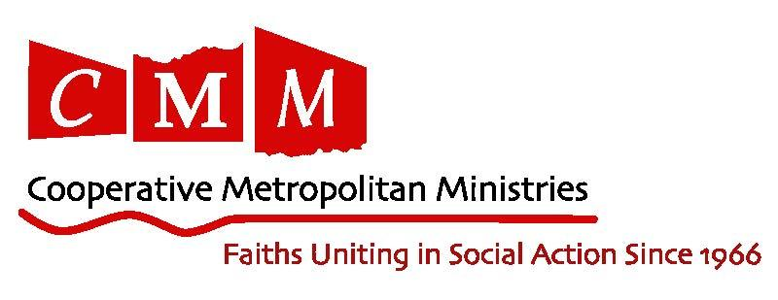
IFYI is a program of CMM (Cooperative Metropolitan Ministries).

Dear Students/Young Leaders, Parents, Youth Educators, Clergy, and Community Leaders,

Hello IFYI friends, new and old! We are hard at work to prepare for IFYI Summer Fellowship 2020. Here are some of the new and innovative details of what we have in store for this year’s program:

First and foremost, we are excited to announce the dates and theme of IFYI 2019: Wednesday, July 22nd - Tuesday, July 28^{tht}, “Becoming an Upstander and Stand Up For What is Right“.

IFYI 2020 will continue to work on developing our core values of learning and engagement, transformative leadership, bridge-building competence, and collective service and action. Our goal is to help participants strengthen their practical skills as leaders within their communities, their sense of unique identity and gifts (both natural and developing), and their ability to build relationships across religious, cultural, political, social and other boundaries. This year will focus on the opportunities for action that bring our communities together by celebrating our diversity and bettering our communities by knowing more about one another.

IFYI is an opportunity for young people to learn about their own different identities and the various identities of others, not by sitting in a classroom or reading a textbook, but by building relationships and through hands on experience, dialogue and interactive facilitation. It is also an opportunity to come together around service projects and leadership training that start with IFYI but continue well beyond our time together. The unique part of the IFYI Summer Fellowship: it’s not just about the programs and the learning, it’s about the people, and the IFYI Fellows are the best! Ready to join in the fun? Ready to grow and make a unique contribution by being fully you? Ready to forge a way forward together on common ground amidst beautiful difference? Come join us! We’re honored to have you apply with us!

Please check out our website and fill out an application (found at http://coopmet.org/ifyi) and contact us by email at IFYI@coopmet.org with any questions, and we will see you in the summer!

All our best,
Shelton Oakley Hersey
IFYI Program Director

2020 IFYI Staff Mentor Team

