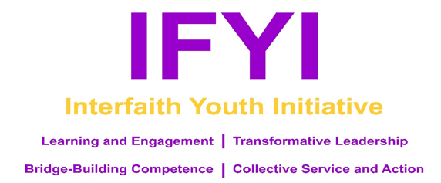

INTERFAITH YOUTH INITIATIVE (IFYI) SEEKS GRADUATE THEOLOGICAL STUDENT TO SERVE AS STAFF MENTORS FOR 2020 SUMMER YOUTH FELLOWSHIP PROGRAM

IFYI is staffed by graduate theological students in the Boston-area interested in guiding and mentoring young leaders (ages 15-19) through an immersive interfaith fellowship program designed to cultivate leadership, bridge-building skills, service and a spirit of lifelong learning.
For more information about IFYI, please visit our website: coopmet.org/ifyi.

● WHEN? July 22nd-29th & availability for full two-day training (dates TBD) ●
● WHERE? Brandeis University, Waltham, MA ●
● STIPEND: Staff members are paid $1000, lodging and meals provided ●

Responsibilities include:
- Attend and be on time for Staff Mentor meetings during the program in addition to all days of program and training.
- Help create and maintain a safe space for all participants and minors in particular according to ground rules and agreed upon Community Commitments.
- Help create and maintain a positive, welcoming, pleasant, respectful, safe, inclusive and transformative community throughout the duration of the week by:
- Taking the initiative to get to know each student by name early in the program,
- Being a presence willing to address the needs of students,
- Modeling positive behaviors such as respectful communication, applying active listening, practicing self care (like going to bed on time and communicating the need for personal reflective space), including everyone, limited and intentional usage of cell phones, and full participation
- Overseeing the students in dorms on location, including the maintenance of various Ground Rules (in the Staff Guide to be received at the training retreat).
- Active mentorship of youth and individual consultation and/or spiritual, emotional, relational and mental guidance of students.
- Create, prepare and lead or co-lead (opt. with another mentor) one or more workshops or interactive dialogue in your area(s) of expertise/passion. The IFYI Program Director will help coach and guide you in this.
- Participate, support and assist other staff and students during large group activities and off-campus outings.
- With another mentor plan and lead at least 1 “morning circle” or evening fun activity during the program week. (Details on these spaces will be provided during training.)
- Co-facilitate and lead Reflection Cohorts, which entail:
• Preparing for and facilitating discussions based on our shared experiences, workshops, and city excursions
• Being a pastoral presence willing to address the needs of students for the duration of the program,
• Helping youth in your group to plan and lead one morning or evening “interfaith circle” during the week,
• Empowering youth in finding their voice on issues of justice and reconciliation
- Lead/Co-Lead two back-to-back “Exposure Activities” according to your particular spiritual identity.
- Lead/Co-lead and coach Expression Cohorts (either music, photo/film, drama, art, dance, or writing/spoken word) in preparation for the Closing Celebration on the last day of IFYI and participate in Closing Celebration.
- Guide youth Fellows throughout the week in reflecting upon the IFYI theme “Becoming an Upstander and Stand Up for What is Right” and its meaning both in today’s world and for the participants’ possible future vocations.
- Help recruit new IFYI youth Fellows if you are able.

Email the IFYI Program Director, (IFYI@coopmet.org) with your resume for further information and application.
We would love to buy a cup coffee with you and discuss this unique opportunity!
Application deadline: April 15th, 2020. Thank you so much!

